73.10.08c
From Ernest Wuth
RB MSS M1, Library, Royal Botanic Gardens Melbourne.

8th October 73
Sanderson's on the Road to Springsure & Barcoo
90 miles from Rockhampton
My dear Baron
I have much pleasure to inform you that this day about 8 miles from Gainsford my servant and self found the first time undoubtedly the fruit of Eucalyptus citriodora. You will no doubt at once recognise in packet No. I the leaves and bark as from Eucalyptus citriodora; well then, those are from a shoot about three feet high coming just an inch above the ground from the old tall and well proportioned tree of which the seed or rather fruit (ripe) in packet No. II is procured. You find also some dry bark of the young shoot in the same packet. But, what do you say when I again send you in packet Nr. III leaves like those I formerly sent you with the supposed seed of Eucalyptus citriodora. This packet also contains the dry outside layer of the bark of the old tree. I must however add, that neither the seed nor those leaves were taken direct from the old tree, no, the former were picked up from the ground quite close to the tree, likewise the supposed leaves from the old tree. But we could plainly see, that those of the tree were of the same peculiar shape. You may ask, why not taking them from the tree direct? The answer is, that was in the bush an impossibility. The tree about 3 feet in diameter had with the exception of the young shoot no branches for upward of 80 feet or perhaps 90 feet and the bark was quite smooth like that of a birch-tree and we had no saw at hand. We saw plainly the thick clusters of the little fruit on the summit and I repeat, the leaves which had exactly the small or narrow shape of those we found underneath. There was no other kind of tree for a considerable distance and the forrest was crowded with those elegant trees. Interesting it would be to know, whether with the alteration of the smaller & narrower shape of the leaves with the age and the growth of the same tree the beautifull odor gets also lost in the fresh leaves, as in the dry ones it is deficient. This question shall be settled by me in time, if I find the same tree at the Barcoo. To give a clear idea of the whole trunc and shape of the tree looke at this:

The tree was about 120 feet high
Yours faithfully
Dr. E M Wuth.

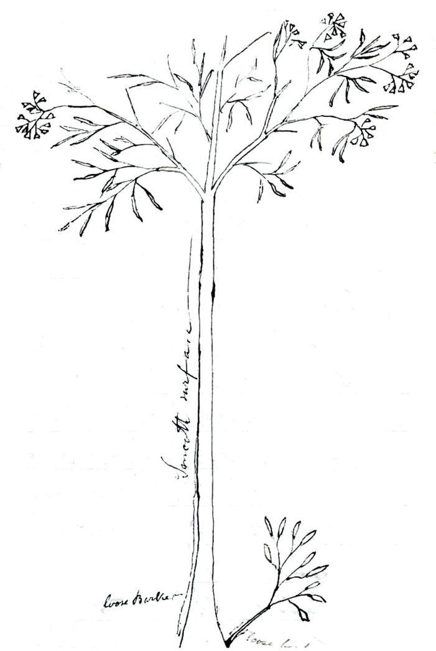

Eucalyptus citriodora

MS found with specimen of Eucalyptus citriodora (MEL 1609874) collected by Dr Wuth, Barcoo, Qld.
Qld.
See E. Wuth to M, 17 June 1871.
There is a sketch of the tree at this point, marked at the bottom of the trunk 'loose Bark' and 'smooth surface' along the rest of the trunk. The thin lined paper allows text on the other side of the sheet to show through. The image has been manipulated to remove the lines and extraneous text: 73-10-08_image01.jpg

